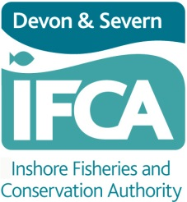

Exemptions Byelaw 2019 - Authorisation Request

Devon and Severn Inshore Fisheries & Conservation Authority (D&S IFCA)
Brixham Laboratory
Freshwater Quarry
Brixham
TQ5 8BA
01803 854648
office@devonandsevernifca.gov.uk.
www.devonandsevernifca.gov.uk

The Exemptions Byelaw 2019 enables the Authority to consider an application relating to scientific work or for stocking or breeding purposes where a fishing activity is undertaken that would otherwise be in contravention of one or more of the Byelaws, or one or more of the permit conditions as set out in the Byelaws. The Byelaws and Permit Conditions can be viewed by visiting D&S IFCA’s website. If you are in any doubt as to whether the intended activity requires an exemption, please contact D&S IFCA before completing this form.

Determination
The application shall be determined by the Authority within 60 days of receipt of the application at the Authority’s office.

In making a determination under this Byelaw, the Authority may consult with other persons as it deems appropriate.

Advice
If required, the Authority will be able to advise the potential applicant or applicants regarding the type and detail of information and evidence that must be submitted to support their application and the subsequent assessment of it.

Completing the Application Form
Please complete all requested details within the form before submitting. This should be done accurately in as much detail as possible. If requested information is missing this may result in the application being rejected or result in D&S IFCA refusing to proceed with the application until the failure is remedied.

Please send the completed application form to the office email address or alternatively post a completed form to the D&S IFCA office.

Your Responsibilities
It is your responsibility to check the details are correct before signing the declaration.

You must not carry out the activity for which the authorisation is required until this completed form has been sent to D&S IFCA and the application has been approved.

The written authorisation shall:

a) be signed by the person determining the application;
b) set out the reasons for granting the written authorisation;
c) state any conditions upon which the written authorisation is granted; and
d) be sent to the postal or email address provided on the application form.

It is the responsibility of the applicant to notify D&S IFCA if any of the details within the application change. If there is any alteration to the submitted work plan there may need to be a further assessment, and this would therefore invalidate the issued authorisation.
Assessment of the Application
Assessment of applications for authorisations will consider environmental impacts. Where an activity will be conducted within a Marine Protected Area, D&S IFCA may need to consult with Natural England. If submitting supporting documents these can be submitted in addition to fully completing this application form and will not be accepted in place of the application form.

- Please be aware that approval can take up to 60 days from receipt of application.

Rejection of Applications
If an application for a written authorisation is rejected, D&S IFCA will give written notice which shall;

- be signed by the person determining the application;
- set out the reasons for declining to grant the written authorisation; and
- be sent to the postal or email address provided on the application form.

Complaints
D&S IFCA has a complaints procedure which is available on the website or upon request.
Section 1: Details of Applicant
. All sections must be completed

1a. Business Name (if applicable)

1b. Name of Applicant

Title | Forename | Surname

1c. Correspondence Details of Applicant

Address | Email | Phone

Section 2: Request for Authorisation
2a. Summary
Please give a description of the proposed activity including its purpose, methodology, species targeted (if any), and all other relevant information.

2b. Location

Where will this activity take place? D&S IFCA requires accurate, precise location information in order to assess the proposed activities and process your application.

Please provide digital copies of GIS files (.shp, .gpkg or similar), and tabulated coordinates where possible. Maps provided to D&S IFCA on this form must be accompanied with the relevant co-ordinate information. Please contact D&S IFCA directly for further advice if required.

If sending positional co-ordinates (latitude and longitude) provide them in Decimal Degree format or GIS format in a .csv file. Other formats will not be accepted unless agreed with D&S IFCA in advance. Data descriptors/labels should be included where appropriate i.e. for point data: Trawl start and Trawl end.

E.g.:
Activity | Lat (decimal degree) | Long (decimal degree) |  | Lat (GIS) | Long (GIS)
Trawl start | 50º 18.4318 N | 003º 34.3195 W |  | 50.30719722 | -3.57199721
Trawl end | 50º 17.4831 N | 003º 37.2594 W |  | 50.29138480 | -3.62099055

Please insert co-ordinates below or attach a csv file with co-ordinates:

Please also provide a brief written description of the spatial parameters of the activity proposed. For example - location, depth, area covered, etc:

c. Activity within a Marine Protected Area or Sensitive Habitat

An interactive map can be found at http://jncc.defra.gov.uk/page-5201 and a chart of MPAs in the D&S IFCA’s District is shown below:
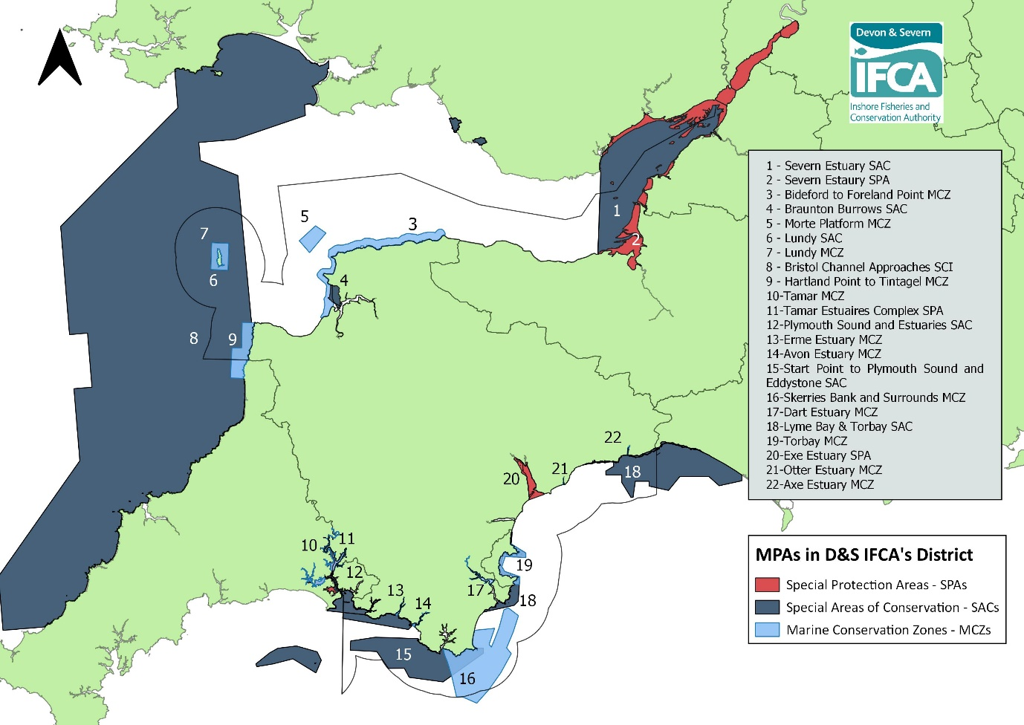

Does the activity take place in an MPA or on sensitive habitats within the D&S IFCA’s District?

Yes No

If Yes, which site/s?

If yes, relevant assessments must be conducted in full by the applicant (for example an HRA or MCZ assessment).

Have any Habitat Regulation Assessments or MCZ assessments been undertaken and submitted to NE?

Yes No
Please give details of assessments and NE advice received (including date):

2d. Time

Requested authorisation start date.

Requested authorisation end date.

Please provide details of the timetable for this project:

2e. Vessel Details
Please note that “vessel” means a ship, boat, raft or watercraft of any description and includes non-displacement craft, personal watercraft, seaplanes and any other thing constructed or adapted for floating on or being submersed in water (whether permanently or temporarily) and hovercraft or any other amphibious vehicle, used or capable of being used as a means of transportation on water.

*If planning on using multiple vessels please provide details for each vessel.

Vessel Name:

Registry of Shipping Number:

Port letters and Numbers:

(if applicable)

Owner of Vessel

Skipper of Vessel

Contact Details of Primary
Vessel Operator
(Mobile No. and Email)

Length of Vessel

Type of Vessel

Detailed Description of Vessel

VHF Channel/s Operated and
MMSI number

2f. Gear Description

Please provide a detailed description of all gears to be deployed:
(e.g. gear type, width of trawl, length of warps, net specifications, mesh size, tow speed and duration, type of weights used, soak time, type/number of pots used etc.)

2g. Mitigation

Please give details of all mitigation measures that will be taken to minimise the impact of the proposed activity on both the environment and other mariners. For example:

- Notifying Harbour Authorities
- Producing Notice to Mariners
- Contacting fishers in the areas worked
- Avoiding deleterious or damaging survey techniques
- Limiting impacts to sensitive features and species assemblages etc.
- Measures to be implemented as a result of NE’s advice

Section 3: Applicant Declaration

I declare that:

The information given in this form is to the best of my knowledge correct and I accept full responsibility for it.

This declaration must be signed by the applicant:

Signature | Name in BLOCK capitals | Title | Date

Please enter the number of continuation sheets attached
(These must be dated and signed)

Please enter the number of supporting documents attached

It is the responsibility of the applicant to notify D&S IFCA if any of the contact details change and if there is any alteration to the submitted survey plan. Alterations may require further assessment and would therefore invalidate the issued authorisation.
What do we do with your information? – D&S IFCA’s Privacy Policy:
D&S IFCA will only hold information about you that is required in order to conduct its functions imposed by legislation. Our lawful basis for this is Article 6 (1) e) of the General Data Protection Regulation 2016. We protect any personal data that you may provide. Any personal data submitted in this application may be shared with other persons or organisations relevant to the assessment of the authorisation. Details of approved authorisations will be published on the D&S IFCA’s website. D&S IFCA has a privacy policy which can be found by visiting our website (home page) www.devonandsevernifca.gov.uk

