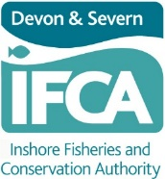
D&S IFCA Developing Recreational Sea Angling Opportunities at Skerries Bank

A Call for Information on the Skerries Bank Angling Zone
What’s the purpose of this information gathering exercise?
The Skerries Bank Angling Zone was one of three sites selected as a pilot study to introduce appropriate fishery management that would proactively develop the Recreational Sea Angling (“RSA”) sector. A Voluntary Code of Conduct was developed which aimed to balance the different sectors’ needs. Data collected in 2015-2016 were used to produce a baseline report which highlighted there is much overlap, both spatially and seasonally, in the use of the site between commercial, recreational and charter boat users. Between data collection and the writing of this report, the Netting Permit Byelaw was introduced in 2018. This Byelaw and associated Conditions prohibit the use of any net in a significant section of the site except where:
- The headline of the fixed net is set at least 3 metres below the surface of the water at any state of the tide
- The net used is a seine net
- The net used is a drift net.

The permitting system allows for adaptive management as changes can be made to the permit conditions, via consultation, if Devon and Severn IFCA (D&S IFCA) consider it to be necessary. This could include limitations or spatial/time restrictions.
D&S IFCA would like to engage with various stakeholders to gather information and evidence to better understand how the Skerries Bank Angling Zone is currently being used across all fishing sectors, whether there has been a change in usage since the Skerries Bank Angling Zone and Netting Permit Byelaw was created, and whether there are any management concerns among stakeholders.
Why is this information needed?
It has been six years since monitoring surveys were conducted on the Skerries Bank Angling Zone. Due to the length of the time since the data collection occurred and the subsequent introduction of the Netting Permit Byelaw, D&S IFCA would like to obtain up to date information on all fishing activities currently undertaken in the Skerries Bank Angling Zone.
This initial request for information will allow us to involve and engage with the users of the Skerries Bank Angling Zone directly and understand management needs in the area. If appropriate, virtual workshops will be held in order for users to debate the current management approach (in terms of the use of the Skerries Bank Angling Zone) and identify potential sources of conflict and their possible solutions. Please indicate below whether you would like a workshop.
How will your information help us?
We will collate the initial information you provide, and this will be used to compare against the baseline report and help to establish whether the Skerries Bank Angling Zone now coupled with D&S IFCA Permit Byelaws provide any benefit to the RSA sector and if the Code of Conduct is still an appropriate form of management for the site. The development of the Skerries Bank Angling Zone will feed into a review of the Authority’s RSA Strategy.

How can you have your say?
Please complete the following questionnaire and return to us via the methods below or call us to discuss the questions over the phone
- Contact us via email s.curtin@devonandsevernifca.gov.uk

- Write to us:
Devon and Severn IFCA
Brixham Laboratory,
Freshwater Quarry,
Brixham,
TQ5 8BA.

- Call us during 10.00am – 15.00pm on Monday, Tuesday and Wednesday on 07590 224014.

THIS INFORMATION GATHERING EXERCISE ENDS ON 9th DECEMBER 2022.
……………………………………………………………………………………………………………
What do we do with your information? – Privacy Policy
We protect any personal data that you may provide. Personal data submitted in this information collecting process will be securely stored. The content of responses will be summarised, where appropriate, and anonymised for documenting in any further reports on the Skerries Bank Angling Zone that will be published on our website.
D&S IFCA has a privacy policy which can be found by visiting our website (home page) www.devonandsevernifca.gov.uk
- You can change your preferences at any time.
- We have a duty to consult with D&S IFCA Permit Holders.
- You can manage your preferences by contacting D&S IFCA.

Awareness
- Are you aware of D&S IFCA? Y/N If No, see Annex 1 (A) below
- Are you aware of the Skerries Bank Angling Zone? Y/N If No, see Annex 1 (B) below.
- Are you aware of the Code of Conduct? Y/N If No, see Annex 1 (C) below.

Skerries Bank Angling Zone Questionnaire
(Recreational anglers)
About you
- Do you fish within the Skerries Bank Angling Zone from a vessel or the shore? If from a private vessel, please state the size (length) of the vessel?

- Which area of the Skerries Bank Angling Zone do you use? (Please use the chart below to determine which grid cells you fish in and indicate them below).
(e.g. C6, D6)

- When and how often do you fish the area(s) advised in Q2 and how many rods do you fish at each site?

- Is there a preferred season to fish the Skerries Bank Angling Zone?

- Why do you choose to fish in the Skerries Bank Angling Zone?

- How long have you been fishing in the Skerries Bank Angling Zone?

- Do you fish for food or sport or both?

- Have you changed your fishing activity/pattern within the site since the creation of the Skerries Bank Angling Zone to now? If yes, please describe how/what you have changed.

- What species do you mainly target in the Skerries Bank Angling Zone? Has this changed over time?

- Have you noticed any changes or patterns in any specific fish species caught (e.g. plaice and rays) within the Skerries Bank Angling Zone in recent years? If so, what proportion of change have you observed in this species?
(e.g. rays have decline and plaice caught later in the season)

- How important is the site to you socially?

- Are you a member of a sea angling club? If so, which one?

- Are you a member of the Angling Trust?

- Would you like to have a virtual workshop to discuss these matters further? Y/N

Management
- Do you think there are any current issues within the Skerries Bank Angling Zone in terms of compliance? See Annex 1 B&C for more information on the Skerries Bank Angling Zone.

- Do you think the Skerries Bank Angling Zone Code of Conduct (Annex 1C) is working? If not, what would you consider to be the most appropriate form of management and why?

- In your opinion is there any conflict between the various user groups of the site e.g. commercial/charter and recreational? Please describe this.

Thank you for taking the time to complete the questionnaire

Please see below for chart and annexes
The chart below shoes the extent of the Skerries Bank Angling Zone. Using the chart and the grid cell numbers, please indicate the locations of your specific fishing activities confirmed in Q2.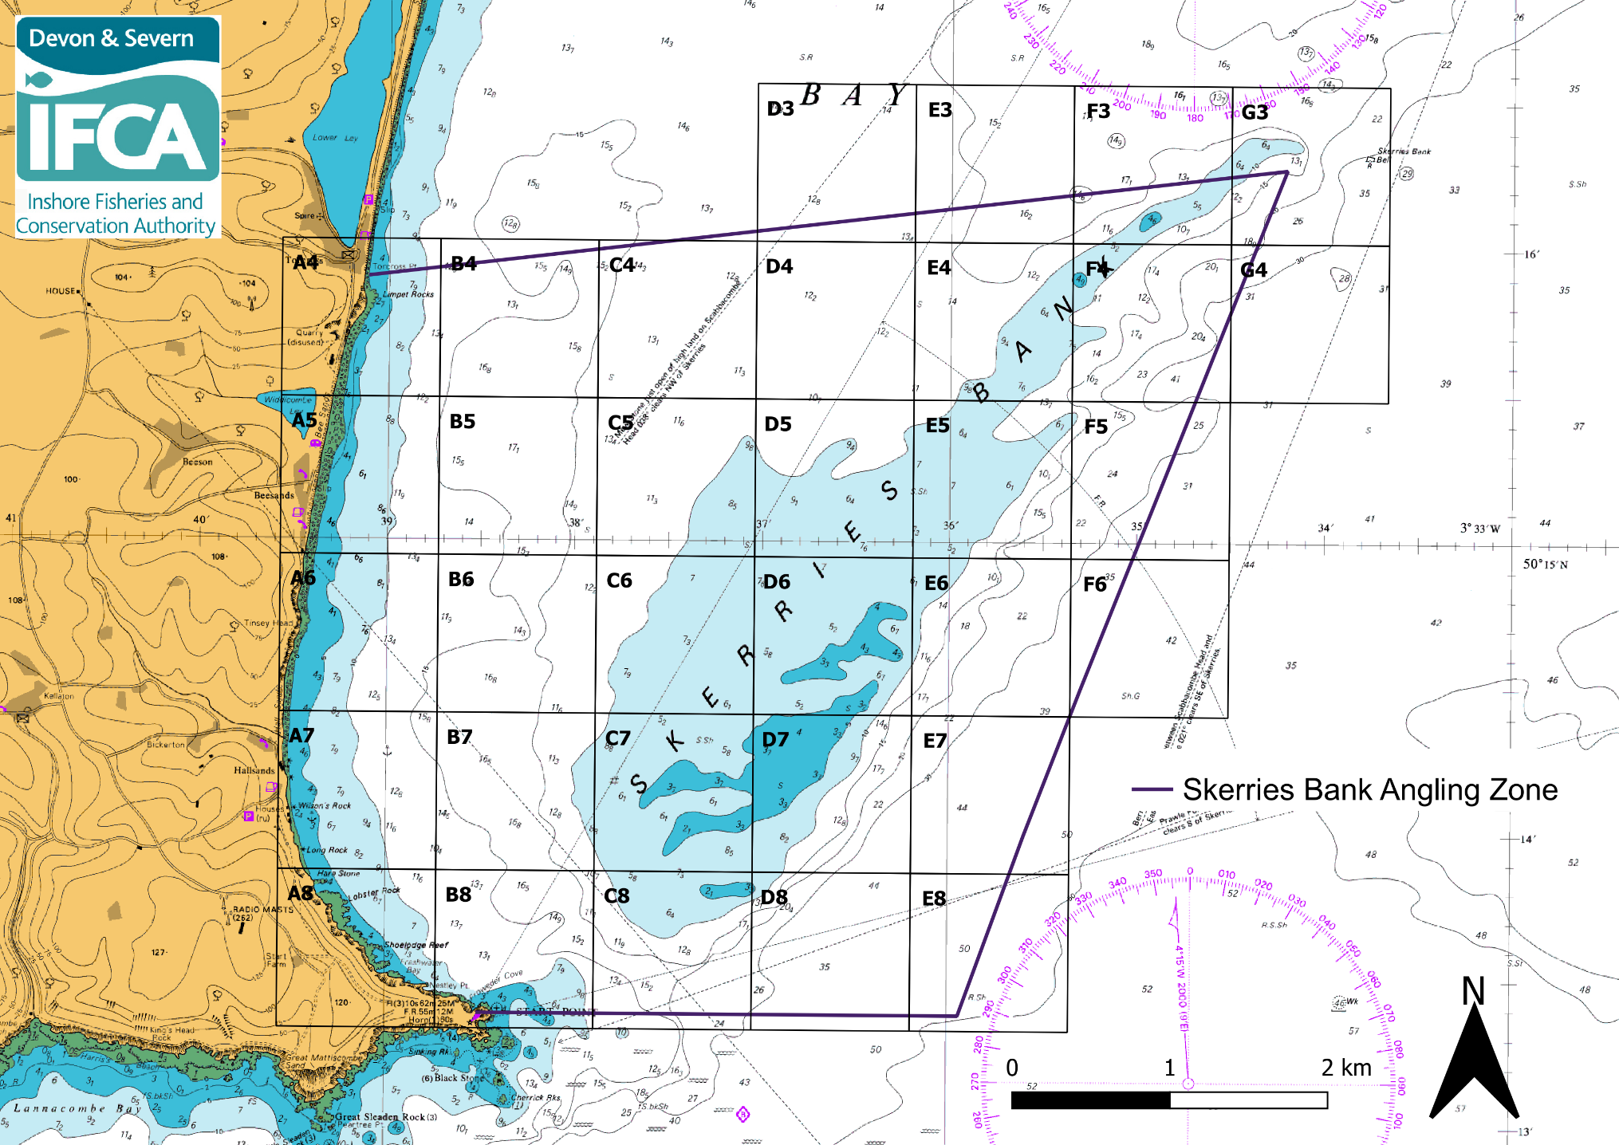
ANNEX 1 – Information on D&S IFCA, the Skerries Bank Angling Zone, and the Code of Conduct

- D&S IFCA
The Marine and Coastal Access Act 2009 (MaCAA) introduced a new framework for managing the marine environment and providing greater access to it. This Act of Parliament replaced Sea Fisheries Committees with Inshore Fisheries and Conservation Authorities (IFCAs) and is fundamental to the work of D&S IFCA. The D&S IFCA is the largest of the ten IFCA Districts (4522 km² in area) and has two separate coastlines. The D&S IFCA’s District includes the areas of Devon, Somerset, Gloucestershire County Councils; Bristol City and Plymouth City Councils; North Somerset and South Gloucestershire Councils and all adjacent waters out to six nautical miles offshore or the median line with Wales.
D&S IFCA’s Mission: “D&S IFCA will lead, champion and manage a sustainable marine environment and inshore fisheries, by successfully securing the right balance between social, environmental and economic benefits to ensure healthy seas, sustainable fisheries and a viable industry”.
- Skerries Bank Angling Zone
Under Section 153 of the Marine and Coastal Access Act, D&S IFCA has a duty to seek to balance the different needs of persons engaged in the exploitation of sea fisheries resources in its District.
In 2012 D&S IFCA was heavily involved in a project ‘Sea Angling 2012 ‘. This was a nationwide study into the economic and social impacts of recreational sea angling involving Cefas, the MMO and the ten IFCAs. As a result of the Sea Angling 2012 Project, D&S IFCA has proactively developed and published their own Recreational Sea Angling Strategy in acknowledgement of the findings. Following the publication of its Recreational Sea Angling Strategy, D&S IFCA worked with RSA representatives on the Authority to identify potential areas/sites where appropriate fisheries management would proactively develop the RSA sector. After a series of consultation events three areas were identified and implemented:
- Skerries Bank in Start Bay
- Burnham, Berrow and Brean Beaches in Somerset
- Emsstrom wreck site, close to Torbay

(C) Code of Conduct
Management of the three sites consists of Voluntary Codes of Conduct, which aim to balance the needs of all user groups by restricting certain commercial and recreational fishing activities to preserve the importance of the areas to recreational anglers and charter boats. The vessel size restriction at Skerries Bank Angling Zone maintains access for small commercial fishing vessels that rely on access to the area.
Skerries Bank
Netting and Longlining
- No commercial targeted fishing for plaice by any method may take place within the entire area of the Skerries Angling Zone.
- Vessels which exceed 10m in overall length are prohibited from engaging in any commercial or recreational netting or longlining activity within the entire area of the Skerries Bank Angling Zone.
- All nets used within the Skerries Bank Angling Zone should be clearly marked using buoys with flags to identify between pots and nets.

Recreational Angling
- There is a bag limit for recreational sea anglers fishing within the Skerries Bank Angling Zone of 10 plaice and 3 rays per angler per day.
- Handle all fish carefully particularly those you intend to return to the sea alive

