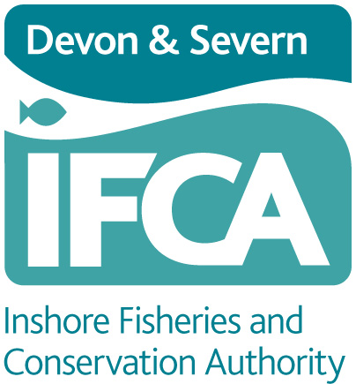

**Authority Members’**

**Information to Return**

May 2022

## **D&S IFCA Privacy Policy**

The information requested in the relevant sections should be completed by Members and returned to D&S IFCA. Personal information will be held securely and used as required and as agreed as per the consent forms. D&S IFCA has a Privacy Policy which can be viewed on the website (home page).

## **D&S IFCA Office Address**

The Office

Devon & Severn Inshore Fisheries and Conservation Authority

Brixham Laboratory

Freshwater Quarry

Brixham

Devon

TQ5 8BA Tel: 01803 854648 Email: [Office@devonandsevernifca.gov.uk](mailto:Office@devonandsevernifca.gov.uk)

## **Members’ Details**

|  |  |  |  |
| --- | --- | --- | --- |
| **Members’ Details** | | Please tick what can be shown on the public pages of D&S IFCA Website | Please tick what can be shown on the Members’ Secure Area of the website. |
| Name |  |  |  |
| Title and Decoration (Mr, Mrs, Miss, Prof, Dr, Cllr, MBE etc) |  |  |  |
| Address and Post Code |  |  |  |
| Telephone Number/s |  |  |  |
| Email address |  |  |  |
| Occupation |  |  |  |

## **Personal Interests**

Notification by Elected/General Member of Devon & Severn IFCA of personal interests (to return)

PLEASE READ THE STANDARDS BOARD FOR ENGLAND “CODE OF CONDUCT. Guide for Members May 2007” & THE STATUTORY INSTRUMENT 2007 No.1159 LOCAL GOVERNMENT, ENGLAND AND WALES The Local Authorities (Model Code of Conduct) Order 2007.

I, (*full name)*

am an elected Member / appointed General Member (delete as necessary) of Devon & Severn Inshore Fisheries and Conservation Authority

GIVE NOTICE that I have the following personal interests:

(a) My Employment / Business carried on by me (*delete whichever does not apply)*

(b) I am a member or in a position of general control or management for the following bodies:

(c) Details of personal interests *(if you have no interest in this category please state ‘None’)*

(d) Details of pecuniary interests *(if you have no interest in this category please state ‘None’)*

Signature_______________________________________ Date__________________

NOTE:

A member must within 28 days of becoming aware of any change to any interests specified above or register details of any new interest by providing written notification to the authority’s monitoring officer of that change.

## **Declaring interests at meetings (to return)**

I agree to declare my registered interests at any meeting I attend where a relevant matter is being considered.

I may have other interests in a matter being considered at a meeting I attend, that I do not have to include in the Register. These could be other pecuniary, or non-financial, interests which arise because the matter affects me, or someone connected with me, more than it affects the general population. I agree to declare these interests as they arise.

In deciding whether I should declare an interest of this type, I will consider whether a reasonable person who knew about the interest would perceive me as acting inappropriately if I did not declare it.

**Voting at meetings**

I will not take part in the vote at a meeting on a matter that directly or indirectly affects:

any income received, or expenditure, by me personally or by one of the people described in the declaration of interests.

any income received, or expenditure, by an organisation described in the declaration of interests.

I agree to accept the advice of the Chair on whether I can vote at a meeting on a matter in which I have declared an interest.

**Participating in discussion at meetings**

In taking part in the discussion of a matter in which I have an interest, I will ensure that my contributions relate only to the specialist knowledge or experience for which I was appointed to the Devon & Severn, and do not improperly seek to favour my own interests or those of anyone connected with me.

**Delegated authority to make decisions alone**

If I have delegated authority to make decisions or carry out actions on behalf of the Authority, I will ensure that I do not do anything in connection with a matter in which I have an interest, apart from notifying the Chief Officer at the earliest opportunity to ensure that the matter can be dealt with effectively in another way.

**SIGNED:**

**DATE:**

## **Registration of receipt of gifts and hospitality (to return if relevant)**

If I receive any gift or hospitality over the value of ₤25 related to my role as a member of the Authority, I will notify the Chief Officer in writing giving details of the gift or hospitality and the date I received it, for inclusion in the Devon & Severn IFCA Register of Gifts and Hospitality.

In accordance with Authority’s Code of Conduct, I hereby register that I have recently received the following gifts and/or hospitality over the value of £25 in my capacity as a Member of the Devon & Severn Inshore Fisheries and Conservation Authority.

Description of Gift or Hospitality

Date of Receipt:

*(NB: You must register gifts and hospitality within 28 days of receipt)*

Signed: ……………………………………………………

Name:

[in block capitals please]

Date: ………………………

**End**