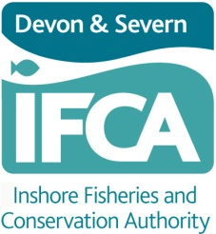
Exemptions for Maintenance Purposes

Exemption Request Form

Devon and Severn Inshore Fisheries & Conservation Authority (D&S IFCA)
Brixham Laboratory
Freshwater Quarry
Brixham
TQ5 8BA
01803 854648
exemptions@devonandsevernifca.gov.uk.
www.devonandsevernifca.gov.uk

Overview
Under paragraph 5 of the Size of Fishing Vessels Byelaw 2022, it is possible for the D&S IFCA to provide a written Authorisation for relevant fishing vessels over 14.99 metres in overall length to operate within the District for specific maintenance, scientific, stocking or breeding purposes. This authorisation request form may be used to request a written authorisation for maintenance purposes. Please contact D&S IFCA for an alternative form for other activities, or for maintenance exemption requests at short notice.

Maintenance Activities Requiring an exemption
Any activity, by a relevant fishing vessel over 14.99 metres in overall length, that requires deploying, towing, pushing or hauling of the fishing gear would require an exemption.

Maintenance Activities that will not be considered for an exemption
The following activities will not be considered for exemption:
- Activities that are directed towards adjustment or refinement of the fishing gear.

Maintenance Areas
D&S IFCA has established two specified areas within the District, in which these maintenance activities may be carried out in accordance with an authorised exemption. These areas are specified in Annex 1 to this request form.

Applying for an Exemption
For requests at short notice, please call the D&S IFCA Office on 01803 854648 so that a D&S IFCA Officer can complete the form on the applicant’s behalf. The Officer completing the form will (i) talk the Applicant through the required information, (ii) confirm that the required information has been recorded correctly, (iii) determine whether an exemption is required, and (iv) determine whether it is possible to authorise the exemption request with the information provided.

If an exemption from D&S IFCA’s Size of Fishing Vessels Byelaw can be authorised, the D&S IFCA Officer will talk the Applicant through the Applicant’s responsibilities (see below), and the conditions of the Authorisation. The Applicant will be deemed to have accepted the conditions of the Authorisation once any maintenance activities are carried out by the specified vessel within D&S IFCA’s District.
For requests submitted in advance, please complete all required details within the relevant parts and sections of the form below before submitting to D&S IFCA at the dedicated exemption request email address (exemptions@devonandsevernifca.gov.uk).

This should be done accurately in as much detail as possible. If required information is missing this may result in the application being rejected or delayed, or result in D&S IFCA refusing to proceed with the application until the failure is remedied.

Your Responsibilities
It is your responsibility as the Applicant to check the details are correct before agreeing to the declaration in section 4, and to abide by the terms of that declaration and the conditions of the Authorisation. If applying by phone, the D&S IFCA will check verbally that the Applicant agrees to the terms of the declaration in section 4.

The activity for which the authorisation is requested must not begin until after the signed written authorisation has been issued to you by D&S IFCA. You must inform D&S IFCA via telephone before any of the authorised activities take place, and again once the authorised activities have been completed.

It is the responsibility of the applicant to notify D&S IFCA if any of the details within the application change. If there is any alteration to the submitted work plan there may need to be a further assessment, and this would therefore invalidate the issued authorisation.
Determination
Simple applications, such as relevant fishing vessels over 14.99 metres in overall length wishing to conduct maintenance in the areas of the District specified in Annex 1 (Torbay or Plymouth areas) will typically be considered and processed on the same day.

If granted, the written authorisation shall:

a) be signed by the person determining the application;
b) set out the reasons for granting the written authorisation;
c) state any conditions upon which the written authorisation is granted; and
d) be sent to the email address(es) provided on the application form (or by the Applicant over the telephone).

Rejection of Applications
If an application for an authorisation is rejected, on request D&S IFCA will give written notice which shall set out the reasons for declining the authorisation.

Complaints
D&S IFCA has a complaints procedure which is available on the website or upon request.

What do we do with your information? – D&S IFCA’s Privacy Policy:
D&S IFCA will only hold information about you that is required in order to conduct its functions imposed by legislation. Our lawful basis for this is Article 6 (1) e) of the General Data Protection Regulation 2016. We protect any personal data that you may provide. Any personal data submitted in this application may be shared with other persons or organisations relevant to the assessment of the authorisation. Anonymised details of approved authorisations will be published on the D&S IFCA’s website. D&S IFCA has a privacy policy which can be found by visiting D&S IFCA’s website (home page) www.devonandsevernifca.gov.uk

Request Form

This request form is only applicable in relation to maintenance activity conducted by relevant fishing vessels above 14.99 metres in length.

- Details of Applicant
Role (Master/Owner/Agent):
Forename:
Surname:
E-mail:
Phone number:
E-mail required to send request confirmation and authorisation letter

2. Details of Vessel, Owner, and Master where not provided above

Vessel Name:
Port Letters and Numbers:
Overall Length of Vessel:
Owner of Vessel:
Master of Vessel:
Does the vessel have a valid Certificate of Registry? (Yes/No)
Does the vessel have a valid Fishing Licence? (Yes/No)
Mobile Number of Master on day of maintenance:
E-mail of Master on day of maintenance (if not provided above):

3. Details of Maintenance Activity
Activity, including details of gear:
Purpose:
Activity Date:
Expected start time and duration:
Location (must be within maintenance areas specified in Annex 1):

4. Applicant Declaration

I, the Applicant, declare that:

- The information given in this form is to the best of my knowledge correct and I accept full responsibility for it;
For all activity to which this form relates,
- I understand that the master of the vessel at the time of maintenance must contact Devon and Severn IFCA via telephone prior to and on completion of the maintenance work;
- I understand that AIS must be active at all times;
- I understand that maintenance activity must only take place in one of the maintenance areas defined by D&S IFCA in Annex 1 to this form;
- I understand that no sea fisheries resources may be retained, consumed, sold or otherwise prevented from being immediately returned to the sea; and
- I understand that I will not be authorised to carry out activities that are directed towards adjustment or refinement of the fishing gear, and that the maintenance activities are to be directed towards maintenance of the vessel and equipment required to operate the gear (e.g. hydraulics), rather than directed towards refining fishing capability of the gear itself.

This declaration must be signed by the applicant completing the form or, for telephone applications, the D&S IFCA Officer will record the Applicant’s agreement to the above terms:

Signature | Name in BLOCK capitals | Date

Annex 1. Size of Fishing Vessels Byelaw 2022 Exemption Areas for Maintenance Purposes

Torbay Maintenance Area

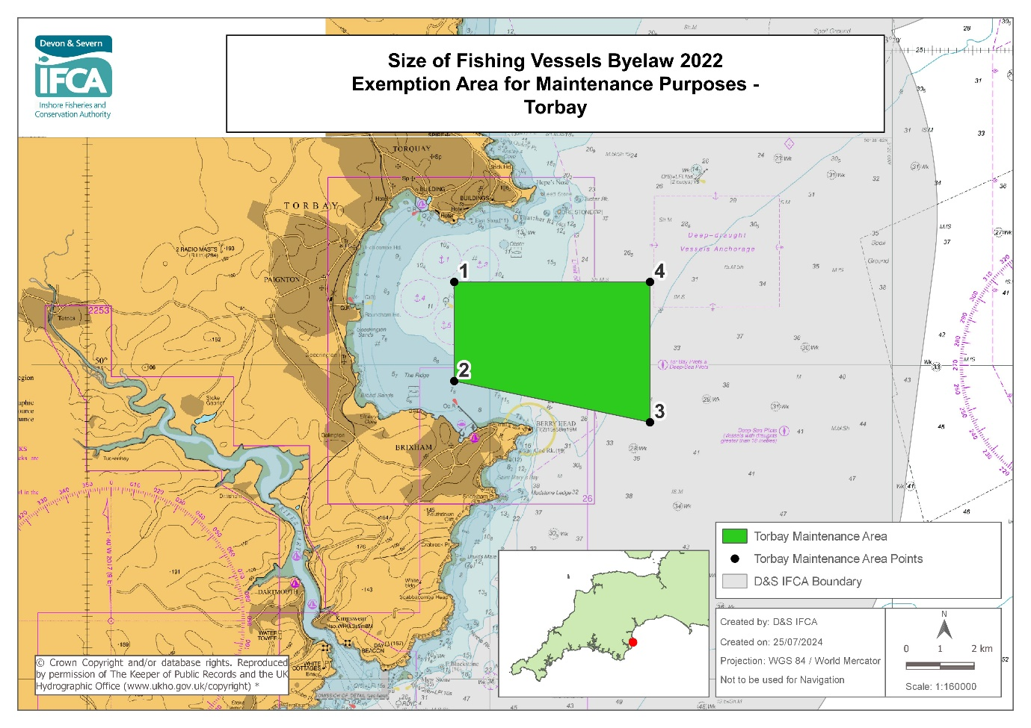
* www.ukho.gov.uk/copyright/
Exemption area for maintenance purposes for relevant fishing vessels that are over 14.99m in overall length within the D&S IFCA District outlined by the following Points plotted sequentially from Point 1 to Point 4 then returning to Point 1.

Point Number | Latitude | Longitude
1 | 50º 26.310 N | 003º 30.882 W
2 | 50º 24.736 N | 003º 30.882 W
3 | 50º 24.080 N | 003º 26.020 W
4 | 50º 26.310 N | 003º 26.020 W

All Positions are expressed in degrees, decimal minutes (DDM) and shall be measured according to the WGS84 Geographic Co-ordinate System

Plymouth Maintenance Area

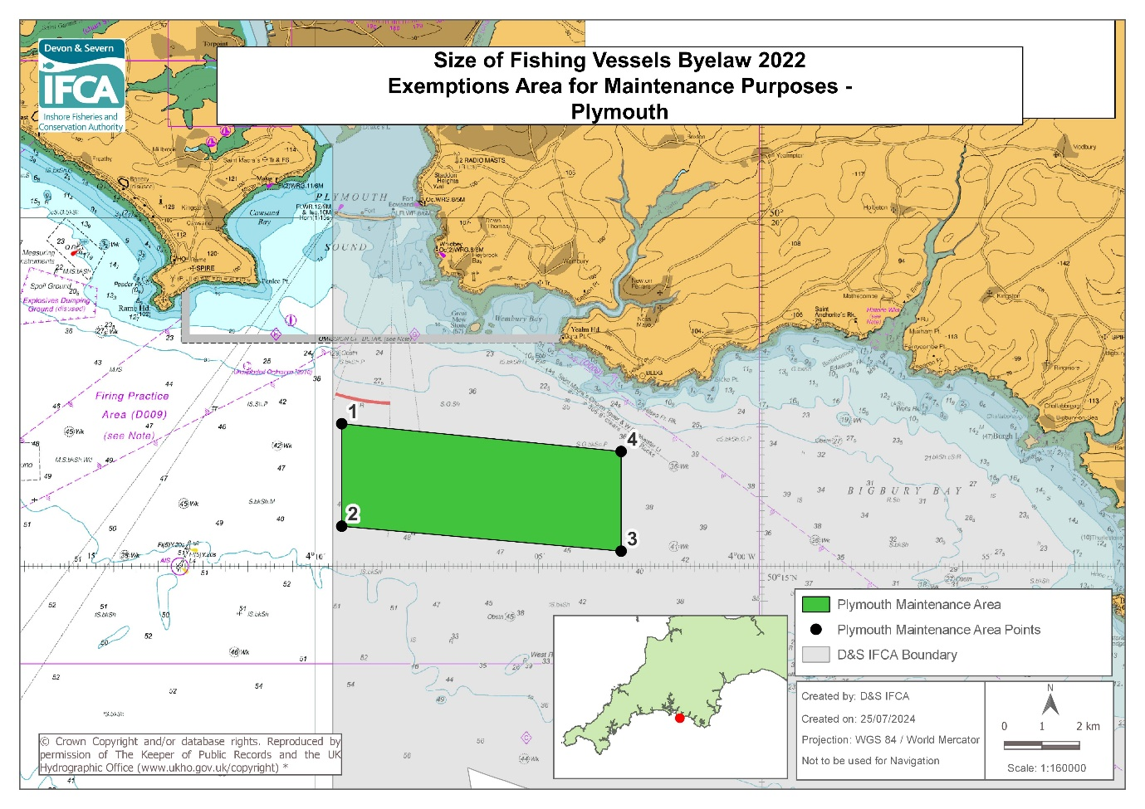
* www.ukho.gov.uk/copyright/
Exemption area for maintenance purposes for relevant fishing vessels that are over 14.99m in overall length within the D&S IFCA District outlined by the following Points plotted sequentially from Point 1 to Point 4 then returning to Point 1.

Point Number | Latitude | Longitude
1 | 50º 17.040 N | 004º 09.400 W
2 | 50º 15.570 N | 004º 09.400 W
3 | 50º 15.212 N | 004º 03.150 W
4 | 50º 16.642 N | 004º 03.150 W

All Positions are expressed in degrees, decimal minutes (DDM) and shall be measured according to the WGS84 Geographic Co-ordinate System

As defined in the Size of Fishing Vessels Byelaw 2022 – (a vessel that has both a valid Certificate of Registry and a valid fishing licence).

